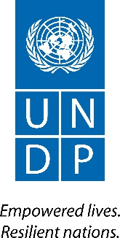

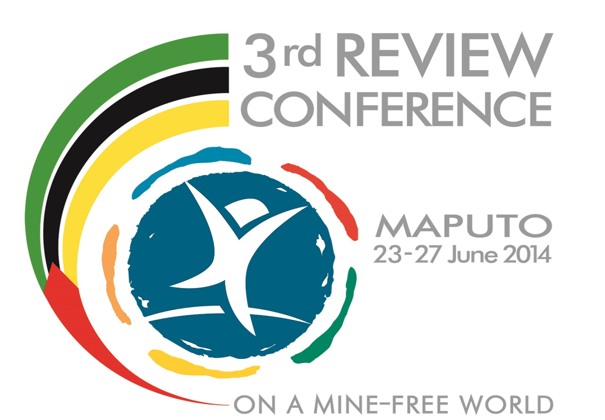

United Nations Development Programme Mozambique
Support to Mozambique Mine Action Programme

FINAL REPORT TO THE 3RC DONORS

EXECUTIVE SUMMARY
From the 23rd to the 27th of June 2014, Mozambique hosted the Maputo Review Conference on a Mine-Free World, the name given to the Third Review Conference of the Convention on the Prohibition of the Use, Stockpiling, Production and Transfer of Antipersonnel Mines and on Their Destruction. The Government of Mozambique requested that UNDP provide support in the organization and hosting of the conference. As such, the output of this project is the successful hosting of the Maputo Review Conference.
The review conference concluded successfully with the adoption for four outcome documents: Maputo+15 Declaration, Review of the 2010-2014 Cartagena Action Plan, 2015-2019 Maputo Action Plan, and decisions on the conventions machinery and meetings. These documents will guide global mine action in the coming five years until the next review conference is held in 2019.
The project progressed well with the support of numerous national and international partners. There were challenges in organization given the scale of the event, the conference-hosting capacity challenges in Maputo and the decentralized nature of the team.
The following report will outline the context and background of the Maputo Review Conference (Section 1) and the results of the project (Section 2). It will then review the performance and implementation of the project, with respect to gender mainstreaming, inclusion of persons with disabilities, national ownership etc. (Section 3). In Section 4, this document looks at the management of the project. This is followed by a brief ‘lessons learned’ section.

CONTEXT
The Maputo Review Conference on a Mine-Free World was a review conference of the Anti-Personnel Mine Ban Convention, signed in 1997 and entered into force in 1999. The Convention mandates that such a conference be held every five years. The Maputo Review Conference was therefore the third review conference, the second was held in Cartagena, Colombia; the first was held in Nairobi, Kenya.

The National Institute for Demining, IND, is the government body with authority in respect to mine action in Mozambique. The Institute has long had the support of UNDP in the form of technical assistance. When Mozambique was chosen to host the conference, UNDP was requested to provide additional support in relation to the organization and logistics of the conference. In particular, UNDP organized resource mobilization and management of international contributions. Understandably, the principal output in the reporting period was the successful hosting of the conference itself.

Mine action is a priority for Mozambique as it was once one of the most mine-contaminated countries in the world, today it is making outstanding progress in demining –the country may be declared mine-free as early as the end of 2014. Hosting the conference was an opportunity for Mozambique to highlight this success and to mark the progress made since 1999, when Maputo hosted the First Meeting of States Parties to the Treaty.

The key stakeholders in this project were:
- The Government of Mozambique, in particular National Demining Institute (IND) and the inter-Ministerial Commission for Large National Events (CIGENI)
- The UN Office of Disarmament Affairs acting as executive secretary for the review conference (UNODA)
- The Convention’s Implementation Support Unit (ISU)
- States Parties to the Convention
- The International Campaign to Ban Landmines (ICBL)
- National and international Civil Society Organizations (CSO)
- Landmine survivors

Many of these stakeholders were also partners in implementation. IND and CIGENI were key partners as well as Geneva-based partners like the ISU and UNODA. National CSOs were also important partners with respect to organizing parallel events.

PROJECT RESULTS SUMMARY
As stated above, the key output of this project was the successful hosting of the conference. This was accomplished in the reporting period. Key activities implemented by UNDP to achieve this output included resource mobilization, coordination and management of international financial contributions. At the request of the government, UNDP also procured key items necessary for the organization of the conference including tents for side events, transportation for delegates and equipment for the meeting rooms and offices.
The conference was held in the Girassol Indy Village Conference Centre and Hotel in Maputo, between the 23rd and the 27th of June 2014. The President of the Republic, H.E. Armando Guebuza, opened the event. More than 600 delegates from 93 delegations participated in the conference.
The Treaty, the Maputo Declaration and the Maputo Action Plan were discussed at length. Two hour-long side events were held each day except Wednesday where – as it was Independence Day in Mozambique—the day was given over to side events. Notable among the side events was Bridges Between Worlds - the Maputo edition, which was a platform for discussing the importance of assistance to landmine survivors in the broader policy framework for the rights of Persons with Disabilities. This event was opened by HRH Princess Astrid of Belgium and included distinguished speakers such as HRH Prince Mired of Jordan, the Minister of Women and Social Affairs of Mozambique and the UN Special Rapporteur on Disability. In addition to the Plenary and the side events, there was an exhibition space for CSOs, UN agencies, IND and sponsors. There were also events in the evening, such as the IncluArte theatre event, which raised awareness of issues relating to landmine survivors and the rights of people with disabilities.

FUNDING FOR THE 3RC
The success of conference was mainly resulted from the partners’ contributions as below
REVIEW CONFERENCE
Funds channeled through UNDP
Donors | Amount in US$ | Remarks
UNDP (BCPR) | 160,500
The Netherlands | 100,000
Denmark | 100,000
Belgium | 65,907
France | 61,224
Switzerland | 56,625
Ireland | 13,831 | Plus in-kind contribution (1 UNV Communication Specialist)
Norway | 25,064 | Fund CSO preparation workshop
UNDP Mozambique | 52,000
Sub-Total | 635,152
Funds channeled directly to the Government
European Union | 200,000
Embassy of Japan | 150,000
Austria |  | Training for Journalists on Mine Action related issues
Sub-Total | 350,000
TOTAL Contributions to 3RC | 985,152

PERFORMANCE REVIEW
Gender Mainstreaming
Landmines are known to have a gendered impact. In Mozambique, women are more likely to have households roles that involve gathering wood, collecting water and, often, working agricultural land. Men, on the other hand, are more likely to be directly involved as combatants in conflict. Gender as an issue was discussed at the conference and two side events were held that focused on gender issues in mine action.

Human Rights Mainstreaming
The Maputo Review Conference was also an opportunity to raise awareness of the challenges facing persons living with disabilities. Many Mozambican and international groups participated in the conference, frequently under the auspices of the International Campaign to Ban Landmines. The Maputo Review Conference and the Bridges Between Worlds side event was also attended by the UN Special Rapporteur for Rights of Persons with Disabilities. UNDP also liaised with local landmine survivor groups and humanitarian operators to ensure that they had an opportunity to raise awareness. UNDP also ensured that all conference facilities were accessible for persons with disabilities. The use of the exhibition space by these organizations and the events that were held (both side events and evening events) were indicators of the success of this approach. Several organizations (RAVIM and FOMICRES among others) have said they hope to use the momentum of the conference to further their human rights goals.

Impact on direct and indirect beneficiaries
There were a number of different stakeholders in this conference including the host country, the State Parties to the Convention, signatories and non-signatories, as well as numerous, often diverse civil society organizations. The IND (our government partners in this project) were pleased with how the conference went. The Deputy Foreign Minister (and conference president) Henrique Banze said that they felt that important steps had been made in charting the global path. It was broadly remarked that mine action in Mozambique has been very successful but that support must continue to ensure completion of demining and continuing support for landmines survivors.
CSOs also reported that they were pleased with progress at the conference. Local CSOs in particular highlighted that the opportunity to participate in a conference on such a scale was rare for the majority of their members and very beneficial in terms of raising awareness of the rights of persons with disabilities in Mozambique and facilitating a stronger partnership between local CSOs and the Mozambican Government.

Communication and publicity
There was wide national and international coverage of the conference including articles in O Pais and Noticias newspapers, Al Jazeera, National Geographic and BBC News. The ICRC photo exhibition was featured on CNN.

IMPLEMENTATION STRATEGY REVIEW
- Participatory/consultative processes
The preparation for the conference was conducted in direct partnership with IND and the government’s national committee for large international and national events (CIGENI). In addition, weekly meetings were held with CSOs in the months leading up to the conference. These CSOs included RAVIM, FOMICRES, ICBL, ICRC, Handicap International, The HALO Trust; NPA and APOPO.
These partnerships proved to be crucial for the success of the conference. It is also anticipated that the connections between partners will multiply the positive impacts of the conference as CSOs and national organizations are better positioned to harness the conference momentum and improve the lives of those living with disabilities, especially landmine survivors.
- National Ownership
As the host country of the event, the Mozambican government (through IND and CIGENI) participated directly in decision-making. Having demonstrated that procurement processes were compatible with those of UNDP, IND was able to directly administer and help to monitor many of the key organizational and procurement activities.

MANAGEMENT EFFECTIVENESS REVIEW
Due to the short nature of the project and specific nature of the deliverable output of the project, traditional monitoring and evaluation frameworks were not used. However, project workplans and procurement schedules were agreed upon by all partners involved. Unfortunately, the limited number of supplies for conference materials and the late arrival of financial contributions meant that many of the procurement processes could only be concluded late and often immediately before the organization of the review conference. Regular coordination meetings were held between all local and international partners to update all partners on the status of the procurement processes and general preparations for the conference. In the end, all challenges were overcome through team work and cooperation of the national government, UNDP and all partners.

DETAILED PROJECT DESCRIPTION AND LESSONS LEARNED

Project-Related CPAP Outcome | UNDAF (2012-2015)  • Outcome 3: Sustainable and effective management of natural resources and disaster risk reduction benefit all people in Mozambique, particularly the most vulnerable.  • Output 3.2: Local communities participate actively in risk reduction activities and natural resources management in districts at risk.  UNDP CPD (2012-2015)  • Output 3.3: Quality of data and its analysis on mine clearance to meet Article 5 of Anti-Personnel Mine Ban Convention.  Output 3.4: Mechanism for residual risks established to improve socio-economic conditions of mine and UXO affected communities.

- Deliverables
  - Conference content management and coordination – Content was led by the ISU and UNODA and agreed upon with GoM/MoFA. The coordination for a final agenda for the conference and side events was done in coordination between the GoM, the ISU, the UNODA, ICBL, UNDP and in close collaboration with IND. It was possible to achieve a combined agenda that included content, protocol and the cultural events offered by the GoM. The outcome allowed for the agenda achievement as well as a presentation of the Mozambican arts and culture to the delegates. The social side events organized also contributed very positively to combine the show of the positive impacts of mine action with moments of socialization;
  - Conference Venue – The venue was the result of a partnership with the EU and the Office of the Coordinator for European Development Funds (GON) in the Mozambican Ministry of Foreign Affair and Cooperation. UNDP and IND initially prepared the ToRs for this partnership and it was successfully produced, agreed and signed by the parties. All along the process, from planning to delivery, a systematic and close work with the venue management, allowed to respond positively to the challenges posed along the development of the Conference, with the venue management responding positively to overcome the challenges. The challenges were related to a diversified number of suppliers concurring to the same result, namely access to internet and tents’ management. It is to be referred that at the end of the first day of the Conference, the venue decided to provide open and free access to their internet network, in order to overcome the gap created by the installation of the main agreed sponsor provider (TDM). In terms of the tents, the venue management has also agreed to providing services that were not initially planned as necessary, namely, electricity to two of the tents (registration and signature) and daily cleaning;
  - Hotel Accommodation – accommodation was smoothly provided through the agreement established between the hotels and IND. It was only necessary to liaise with hotels in terms of confirming delegates lists and crosschecking with reservations made by IND as well as negotiating for the special rates to be extended, due to late booking by delegates;
  - Transportation – Once procurement was done, transportation was organised by CIGENI, in close collaboration with IND and UNDP CO. While the overall result is positive, and delegates were in general timely transported to and from the venue, the process and its management encompassed some constraints, to be developed in the Challenges and Lessons Learned item. The constraints were overcome in time with the effective and timely intervention and work of the IND and UNDP CO colleagues;
  - Catering – catering was only needed for the side events that took place every day from 12h00 to 14h00. In general it went well. The coffee breaks delivered by the venue, twice daily, could have had a wider and healthier variety;
  - Protocol, Security and Medical Assistance– All under the responsibility and execution of CIGENI. In terms of protocol, it would have benefited from an earlier explanation of the process by CIGENI with ISU and UNODA, in order to have had all aware of the steps and approach. Nothing is to be referred towards Security, it was well planned, delivered and accompanied. Same applies to Medical Assistance – a room was booked to serve as support to the ambulance and where a medical team was installed for the duration of the Conference. No major problems occurred and those that were immediately observed and treated;
  - Visa – Visas were a major issue as not clearly understood by all involved and not resolved in a timely way. Visa waivers and visa payments were taken as different things which implied a last minute resolution and approach between IND and CIGENI. The process required to share delegates’ names from the Conference database also allowed for delays due to last minute registrations, with a direct implication on being able to share names with CIGENI in good time. Again, CIGENI’s reaction contributed to resolve the issues;
  - Promotion and Media – The Conference had excellent media coverage. This success was, in part, a result of a training session for journalists held before the conference and financed by the Austrian Government. During the conference, with the ISU leadership, the CO worked closely with CIGENI/GABINFO representative and, with the materials produced by IND, it was possible to have daily reports on the local TV channels about the Conference and about demining in Mozambique. Three press conferences were held regularly during the conference with a media tent established for use by journalists. Communications Officers from UNDP and ISU regularly assisted journalists to arrange interviews with participants and provide background information on the conference.

- Partnerships

Strong partnerships were the basis for the good outcomes observed.
  - The first partnership to be strongly highlighted is the UNDP CO team partnership. Under stress and with time gone for most of the logistic inputs required, the team reacted always in coordination and promptly to resolve the issues. It demonstrates an underlying capacity to deliver under stress on last minute requirements;
  - The European Union. While the legal confirmation of the venue was required to start up all field activities, this process was significantly delayed, all parties shared responsibility but also the need to adjust to the time constraints and to the contractual differences. Daily discussions as well as all parties’ willingness to adjust were key to eventually signing the agreement just on time to start up the activities. It was of paramount importance the intervention of the IND Director in liaising with the venue owners to ensure that contractual questions would not imply a delay on actions required;
  - CIGENI. While CIGENI came to the stakeholders table late in the process, their intervention was crucial in contributing to the outcome. With their mandate and accumulated ownership, diversified specific staff and experience, they took their role with all their capabilities and limitations to resolve, within their different line ministries, all issues to the best possible; be it the visas and airport, logistics related to the tents set-up, generator or internet, a simple call would accelerate the delivery. Although during the meetings, a certain confusion regarding mandates and responsibilities was observed, with the good communication between the stakeholders it was possible to overcome the differences and establish a one-team approach;
  - Girassol Indy Village. The Girassol Indy Village management and operational staff also responded well to the stress and challenges posed during the first day, reacting positively to resolve them. Problems arose a) from the large number of people and b) from the different suppliers contributing to the same output. Access to internet and the implicit use of different internet networks by the IT equipment, posed a major challenge and stress. As TDM, the event internet and telephone lines supplier, did not manage until the second day of the Conference to install a good and open network, Girassol Indy decided to provide a free and open internet access to their network. This implied that computers and printers had to be re set-up to work with both networks, which was not always easy and direct, costing time and resulting in communication difficulties.
  - The IND. The IND Director and his team played a key role in supporting the implementation and creating one team approach with UNDP. The late involvement of CIGENI caused some problems, which the IND team had to overcome the apparent differences in the institutional problem resolution approach and adapt to the new decisions. On the product delivery, namely, institutional and communication material on demining, bags and invitations, although delivered at the very last moment, the team spirit and dedication contributed to, with the UNDP Country Office support, the delivery of all products needed and agreed upon.
In terms of the intangible results, they were related to the management of different institutional stakeholders being brought to the table too late in the process and with concurrent mandates and expectations. The fact that the UNDP Country Office team, IND and CIGENI only sat together at the beginning of June, when it was possible to table Conference operationalization details and jointly evaluate the Conference’s Host Country Agreement, created a certain ambiance of discomfort and competition towards responsibilities and good results.
Although it took a while, it was possible to soften differences or misunderstandings and agree upon each stakeholder’s role and the process forward, without creating any diplomatic or institutional problems.

- Constraints, Lessons Learned and Recommendations
Constraints or challenges were only related to the late timing in starting the Conference’s implementation and the lack of a moment when all stakeholders, ISU and UNODA included, set to understand one another’s roles. While the negotiations and evaluation of the needed inputs and products started long before the event, the operationalization started far too late to facilitate a smooth operation.
The constraints were of two main types, one linked to the lack of the stakeholders understanding of each one’s role and contribution – and their late discussions – and the other linked to the complex combination of products and suppliers.
It is to be remarked that time, or lack of it, was the element creating more pressure on all implied activities. And although time management was not the fault or responsibility of UNDP, responsibility to overcome the constraints posed by the lack of time fell on the UNDP Country Office’s side.
The UNDP has registered a major lesson learned from this activity: timely organization, planning and responsibility of partners must be undertaken in order to reduce exposure in factors that do not have a major weight on the UNDP Country Office’s portfolio.
This said, the lessons learned are as follows:
  - Stakeholders – ensure timely and clear evaluation and agreement upon each stakeholder’s role, allowing individual tasks and responsibilities. This concurs to avoid eventual institutional differences and mismanagement of each one’s role. It also contributes to save funds and time in duplicated functions. It is also of crucial importance to UNDP Country Office, who is often exposed in the middle and in between GoM counterparts, making it more difficult to resolve and work on what are its respective mandate and operations;
  - Time and planning: a solid and sound work plan, that reflects the different linkages, in terms of time and equipment, should be developed in face of an activity that requires different products, suppliers and stakeholders. This will allow an easier and less stressful procurement, will diminish the differences between stakeholders and will allow a better implementation, monitoring and evaluation;
  - Daily M&E team meetings. It is of crucial importance that the team meets at the end of every day to evaluate what was wrong and what to do to correct it, It also serves to strengthen the team spirit and ensure the team deliveries.
  - Procurement: it implied a diversified number of items, products and suppliers, as already mentioned. This diversity requires a sound knowledge of what it encompasses and not always is it clear if one is not used to, or a technician of, the type of outcome being looked for. Combined with the time shortage, it led to situations that required last minute changes and decisions and the use of the UNDP Fast Track Mechanism. For future events, a lesson that can be taken away is that procurement should consider:
    - All sub-items that compose one product - e.g. buses and diesel; tents, electricity, chairs and cleaning; IT equipment and access to internet; food and toilettes to all staff involved. It must be clearly stated where the responsibility of each sub-item lies;
    - Reduce suppliers that provide the same/similar product as much as possible – e.g. IT equipment and access to internet;
    - Time. As much as possible prepare in due time the Procurement Plan to allow for verification, evaluation and discussion with suppliers/candidates the most effective and efficient way to deliver what is at stake;
    - Technical knowledge. Use technical knowledge, even from within the UN pool of agencies and staff, technical knowledge that may contribute to a simpler and more effective procurement plan.
  - Agenda. Ensure that the venue and the logistics adapt to the effective agenda timings. In this specific case, while the official agenda run 9h00 to 17h00, the 23rd to the 27th, effectively people were at the venue from 7h30 to 20h00 each day and working from the 22nd. This imposes that the venue needs to effectively be prepared to these hours and not the agenda hours (UNDP reorganized Indy Village to clean every night instead of every morning, the generator to work more hours than foreseen and all support staff to be in place earlier than planned). Also, the contracting one day prior to the opening would have served to test all equipment and rectify one day before all that was wrong. Further, it will allow that stakeholders observe and agree upon/rectify what needs to be rectified without having an impact on the overall final set-up – e.g. UNODA wanted to change the stage of the booths, the GoM ordered additional translation booths for the side events tents);
  - Norms and standards: The UN has a number of norms and standards that, when not followed, cause problems for the UNDP Country Office. This was seen in the translation booths and while the Country Office and the supplier were clearly aware of this, compliant booths were not available in the country and there was no time to obtain them from abroad. It is advisable that these situations are listed in the contract and that the final user (in this case ISU and UNODA) are made aware of and agree upon the use of what the market has available;
  - Invoice discount for non-compliance. Contracts should foresee fines for non-compliance of the contract agreements. This would save money but also put pressure on suppliers to deliver properly.
  - Transportation – buses and cars. Although contracted in the last minute and as per CIGENI’s recommendation, four suppliers were contracted to ensure enough means of transportation, all cars were fielded on time and no problems were created by the equipment.

Annexes:
- Daily summary
- “Maputo + 15” Declaration
- Provisional Financial Statement

